# ACKNOWLEDGEMENT

It gives us enormous pleasure to submit a report on “**Style Hub**”. Special thanks and deepest sense of gratitude to our college **New Summit College** for giving us the opportunity to present ourselves on this report within the scheduled time. Our report wouldn’t have been possible without the support and guidance of our respected teachers.Special thanks toour coordinator **Mr. Prawesh Dhungana** and the project coordinator **Mr. Parichaya Adhikari** for their uncreditable support and guidance and thanks for believing on us. We hope that this project has been prepared for the fulfillment of the course requirement.

Yours Sincerely,

Aparajita Subedi [79010444]

# ABSTRACT

This highlights the growing reliance on digital platforms for retail and the increasing integration of social media into e-commerce strategies. But the huge problem is they cannot find out the best e-commerce site where they can buy their stuff, increasing scam and fraud can lead a huge problem. To solve this types of problem we try to develop e-commerce site namely “Style Hub” where customer can buy stuff according to their choice. Style Hub is an online shopping website that aims to make shopping easy and enjoyable for users. It only focus on female customer. It has a secure login system, a wide range of products organized neatly, with clear descriptions and pictures, and it even lets you read reviews from other customers. When you find something you want to buy, you can add it to your shopping cart, which keeps track of what you're buying and how much it will cost. The website works well on computers, tablets, and phones, so you can shop from anywhere. While making the website, we paid attention to what it should do and how it should look, and we also tested it to make sure it worked as expected. The goal is to make it easy for people to find and take online shopping.

**Keywords*:*** *e-commerce, Style hub, online shopping*

# TABLE OF CONTENTS

ACKNOWLEDGEMENT ii

ABSTRACT iii

TABLE OF CONTENTS iv

LIST OF FIGURE vi

List of Table vii

LIST OF ABBREVATIONS viii

CHAPTER 1. INTRODUCTION 1

1. Introduction 1

2. Problem Statement 1

3. Objectives 1

4. Scope and Limitation 1

5. Development Methodology 2

6. Report Organization 2

CHAPTER 2. 4

BACKGROUND STUDY AND LITERATURE REVIEW 4

1.1 Background 4

1.2 Literature Review 4

CHAPTER 3. 6

SYSTEM ANALYSIS AND DESIGN 6

3.1 System Analysis 6

3.1.1 Requirement Analysis 6

3.1.2 Feasibility Analysis 7

3.1.3 Object Modeling using Class and Object Diagram 8

CHAPTER 4. 14

IMPLEMENTATION AND TESTING 14

4.1.1 Tool Used 14

4.2 Testing 15

4.2.1 Unit Testing 15

Testing Admin Panel 15

4.2.2 System Testing 20

CHAPTER 5 25

CONCLUSION AND FUTURE RECOMMENDATION 25

5.1 Conclusion 25

5.2 Future Recommendation 25

Reference 27

Appendices 28

Appendices A: Screenshots 28

# LIST OF FIGURE

Figure 1.1: Iterative Waterfall Model 2

figure 3.1: Use Case Diagram………………………………………………………………6

Figure 3.2:Class Diagram 9

Figure 3.3: ER Diagram…………………………………………………………………..10

Figure 3.4: Context Diagram……………………………………………………………...11

Figure 3.5: Level 0 DFD………………………………………………………………….11

Figure 3.6:Sequence Diagram 12

Figure 3.7:Activity Diagram 13

# List of Table

Table 1: Gant Chart…………………………………………………………………………..16

Table 2: Admin Panel Testing 15

Table 3: User Panel Testing 18

Table 4: System Testing 20

# LIST OF ABBREVATIONS

B2C Business-to-Consumer

CSS Cascading Style Sheets

DFD Data Flow Diagram

ER Entity-Relationship

HTML Hyper Text Markup Language

PHP Hypertext Preprocessor

XAMPP X (Cross-platform), Apache, MySQL, PHP, and Perl

# CHAPTER 1. INTRODUCTION

## Introduction

E-commerce refers to the buying and selling of goods and services online. It enables businesses and consumers to trade digitally using websites, mobile apps, and online payment systems. The internet is growing really fast, and because of that, online shopping is also getting bigger. There are different ways to do online shopping, and we’re using the B2C model for our website.

In this project we have tried to make e-commerce site namely “Style Hub” where customer can buy stuff according to their choice. We only focus on a female in our website where they can find all the girly items. It is very difficult to find out the all items for girls

Our goal with this website is to give you a convenient way to buy a girl’s item like clothes, jewelry, shoes and watches online. And when you want to pay for your purchase, you can do cash on delivery for prevent online scam and frauds.

## Problem Statement

Girls typically face high barriers when buying clothes both offline and online. The barriers are of the type of inconsistent consistency of sizes across brands, low availabilities of products that are current or of suitable ages, deceptive presentations of products on the World Wide Web, and inflated prices for fashion products. Further, the availability of many substitutes and peer pressure or social trends could confuse girls and inhibit decision-making. For socially responsible consumers, the deficit of transparency in production and sourcing further adds to the purchase decision. These issues are a plea for the necessity of an easy-to-use consumer-friendly and personalized shopping platform that can address such issues, with credible, affordable, and ethically sourced fashion clothing

## Objectives

The main objectives of this project is:

* To develop a web-based e-commerce platform.

## Scope and Limitation

The scope of the Style Hub Management System includes:

* Provide a single platform for all the girl’s product.
* User-friendly interface for user

The limitation of the Style Hub Management System includes:

* Initial Product Availability: The platform may initially lack a comprehensive range of products as it relies on partnerships and contributions from manufacturers, suppliers, and innovators.
* Technological Limitations: Limited access to advanced technology in underdeveloped areas may hinder some users from utilizing the platform effectively.

## Development Methodology

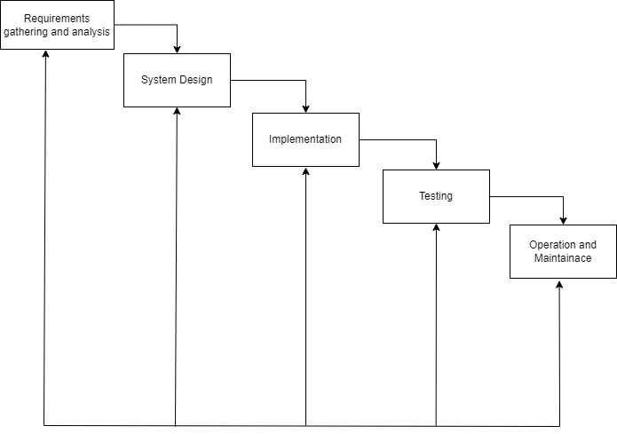Since, All the requirement are clear prior the development of the system and sometimes some small changes can be done so, iterative waterfall model is suitable. The iterative waterfall model can be illustrate as:

**Figure 1-1: Iterative waterfall model**

## Report Organization

This report is divided into four chapter. Each chapter is further divided into different headings.

**Chapter 1** gives an introduction to e-commerce system. The problem definition, objectives, scopes, and limitation of this system are discussed here.

**Chapter 2** focuses on the background study. It consists a literature review section where the research works done in the field of the online shopping website.

**Chapter 3** focuses on the analysis part. It contain a requirement analysis, feasibility analysis and diagram like class diagram, sequence diagram, activity diagram and flowchart. Discusses in detail the design of the system. This chapter also discusses database design, interface design, and flowchart of the system built. This chapter also includes feasibility study, requirement analysis, and diagram like ER, DFD, and flowchart.

**Chapter 4** gives information about the implementation and testing process. It discusses how the system is implemented and what tools and software are used to implement this system. The testing process is also include detail in this chapter.

**Chapter 5** includes the conclusion of the whole project. This chapter shows major achievement in the system and also shows how it can be enhances later in the future

# CHAPTER 2.BACKGROUND STUDY AND LITERATURE REVIEW

## 1.1 Background

The development of e-commerce has transformed the retail sector worldwide, making it possible for businesses to make products and services available to a wider consumer base. The growth of the internet and developments in digital technologies have paved the way for different business models of e-commerce, with the Business-to-Consumer model becoming more prevalent. The B2C model enables businesses to interact directly with end-users by providing convenience, personalized experiences, and hassle-free transactions.

In the past several years, there has been a growing interest in niche e-commerce sites targeting specific demographics. Websites like "Style Hub" occupy a valuable space in the online retail arena—a specialized site exclusively for women's products. It is typically hard to get all the products for women at a single site, and gender targeting enhances ease of access and relevance, targeting female-specific needs and tastes. Product ranges such as clothing, jewelry, shoes, and accessories are not only essentials but also the primary growth drivers in the e-retail business.

The growing need for gender-specific e-commerce sites is due to greater demand for personalized shopping. Cash-on-delivery options also boost confidence by eliminating concerns about online scams and fraud, especially in the emerging economies.

## 1.2 Literature Review

E-business and e-commerce have significantly evolved, shaping both organizational strategies and consumer behaviors. Researchers and scholars have extensively analyzed various aspects of this domain, including managerial perspectives, technological infrastructure, and societal impacts.

Chaffey provides a comprehensive framework for understanding e-business and e-commerce management. The author emphasizes strategic planning, digital business models, and the implementation of online marketing techniques. Chaffey explores how businesses can leverage digital platforms to gain competitive advantages, offering practical insights into successful implementation [1].

Laudon and Traver focus on the intersection of business, technology, and society in e-commerce. Their work delves into technological foundations such as cloud computing, cybersecurity, and artificial intelligence, all of which contribute to the seamless functioning of e-commerce platforms. They also analyze consumer behavior, regulatory policies, and ethical considerations, showcasing how e-commerce shapes social and economic structures [2].

Similarly, Turban, Pollard, and Wood offer a managerial and social network perspective on electronic commerce. Their work highlights the significance of digital ecosystems, including online communities, business-to-business (B2B) interactions, and the role of social media in enhancing customer engagement. They provide insights into how businesses can adapt to the rapid changes brought by emerging technologies and shifting consumer preferences [3].

Collectively, these sources present a holistic view of e-business and e-commerce, demonstrating how strategic implementation and technological advancements drive sustainable digital business models. Their contributions to the field underscore the importance of adapting to an increasingly digital economy while addressing ethical and regulatory challenges [1]– [3].

# CHAPTER 3. SYSTEM ANALYSIS AND DESIGN

The Internet has been favored by more and more people for its high efficiency and

richness, and e-commerce has emerged. The online bookstore is a form of e-commerce

and book sales industry in one form, it has many advantages, such as: Bookstore size is

relatively small, cost savings; transaction activities can be anytime, anywhere, improve

service efficiency, The information is complete, more convenient retrieval, the new book

information on the new, consumers can see in a timely manner, trading activities can be

launched immediately, so online bookstore in today's era of development is extremely

rapid. Online bookstore system is the main function of the trading platform for the site,

consumers can connect to the Internet through the computer into the online bookstore and

then check the book information, if you need to purchase should be registered landing,

select their own books, submit orders and pay Operation to complete the entire book

ordering process, to achieve online transactions.[CITATION Yun17 \l 1033

The Internet has been favored by more and more people for its high efficiency and

richness, and e-commerce has emerged. The online bookstore is a form of e-commerce

and book sales industry in one form, it has many advantages, such as: Bookstore size is

relatively small, cost savings; transaction activities can be anytime, anywhere, improve

service efficiency, The information is complete, more convenient retrieval, the new book

information on the new, consumers can see in a timely manner, trading activities can be

launched immediately, so online bookstore in today's era of development is extremely

rapid. Online bookstore system is the main function of the trading platform for the site,

consumers can connect to the Internet through the computer into the online bookstore and

then check the book information, if you need to purchase should be registered landing,

select their own books, submit orders and pay Operation to complete the entire book

ordering process, to achieve online transactions.[CITATION Yun17 \l 1033

The Internet has been favored by more and more people for its high efficiency and

richness, and e-commerce has emerged. The online bookstore is a form of e-commerce

and book sales industry in one form, it has many advantages, such as: Bookstore size is

relatively small, cost savings; transaction activities can be anytime, anywhere, improve

service efficiency, The information is complete, more convenient retrieval, the new book

information on the new, consumers can see in a timely manner, trading activities can be

launched immediately, so online bookstore in today's era of development is extremely

rapid. Online bookstore system is the main function of the trading platform for the site,

consumers can connect to the Internet through the computer into the online bookstore and

then check the book information, if you need to purchase should be registered landing,

select their own books, submit orders and pay Operation to complete the entire book

ordering process, to achieve online transactions.[CITATION Yun17 \l 1033

## 3.1 System Analysis

System analysis is the process of understanding and comparing the functional impacts of subsystem to the total system. It identifies the problem and organizes the facts and details of the system.

### 3.1.1 Requirement Analysis

As the system design evolves, requirement analysis activities support allocation and derivation of requirement down to the system elements representing the lowest level of the design. The functional and non-functional requirement are necessary to analyze the system requirement before developing and implementing.

**Functional Requirement**

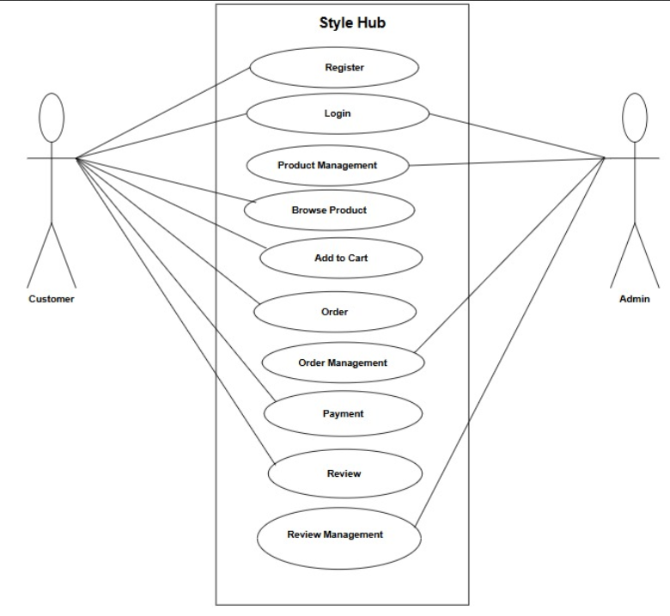The functional requirement specify the documentation of the system and activities that a system must be able to perform.

**Figure 3.1: Use Case Diagram of Style Hub**

**Non-Functional Requirement**

* **Easy to use**

The function and UI are similar other to other e-commerce website making it easy to use and get familiar with the website.

* **Security**

User’s personal information can only be accessed by admin and won’t be available for others. Thus, making system secure.

* **Usability**

This system can be used 24/7 by anyone who is familiar with English language.

* **Responsive**

The system should respond to user actions and requests within a reasonable timeframe, ensuring a seamless and smooth user experience.

* **Maintainability**

The system will be coded and maintained using HTML, CSS, JavaScript and PHP.

### 3.1.2 Feasibility Analysis

The feasibility study shows that the “Style Hub” project is practical and achievable from technical, operational, economic and schedule perspectives.

#### i)Technical Feasibility

The project uses popular and reliable technologies like HTML, CSS, and JavaScript for the frontend and MYSQL as database, ensuring the site is user-friendly and engaging. The backend uses PHP, which is known for being strong, secure, and capable of handling large amounts of data and users so, it is technically feasible.

#### ii) Economic Feasibility

The project is economically viable, because we used all free technology. Hence, the project is economically feasible.

#### iii) Operational Feasibility

The design and structure of the platform are easy for both users and the development team to manage. The platform is simple to navigate, making it accessible for people of all technical skill levels. Clear processes are in place for things like user registration and project submission, ensuring smooth daily operations. The platform is also built to handle high traffic and data, provide reliable performance with accurate data. So, it is operationally feasible.

#### iv) Schedule Feasibility

The project, being small in scale and dependent on various components, will adopt an iterative development methodology. During the process, the system will undergo continuous small-scale modifications.

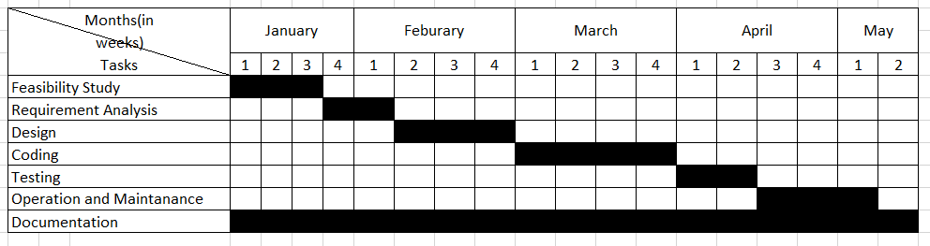**Table 1: Gantt chart**

### 3.1.3 Object Modeling using Class and Object Diagram

#### Class Diagram

The class diagram is the building block of object-oriented modeling. It is used for general Conceptual modeling of the structure of the application. The class diagram below shows the structure of the style hub with the dependencies.

A Class Diagram represents the blueprint of the system. It defines the system's classes, their attributes, methods, and relationships. The main classes include user, product, category, cart and order. For example, the User class has attributes like UserID, Name, Email, password, role and phone with methods such as Register () and login (). The product class includes attributes like product id, name, quantity, price, description with methods to update () add (), and remove (). Relationships are defined as well, such as a User can search a product. While many product have a category .

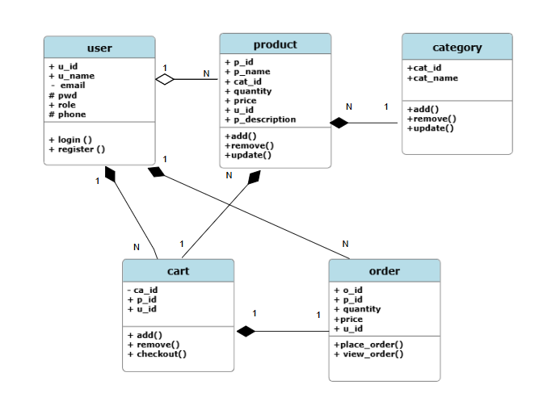

**Figure 3.2: Class Diagram of Style Hub**

The main purpose of class diagram for our project is to build a static view of a system. It is a blueprint of a system as it visualizes the particular working functionality of our system. The UML diagram of Style Hub only depicts the abstract view of diagram

The relationship between classes is justified below:

* Users & Cart (1-to-Many Aggregation)

A user can have multiple cart items, but each cart item belongs to a single user.

* Users & Orders (1-to-Many Aggregation)

A user can place multiple orders, but each order is linked to a single user.

* product & categories (Many-to-one)

Many product belongs to one categories.

* Products & Cart (1-to-Many Aggregation)

A product can be added to multiple carts, but each cart item represents a single product.

* Products & Orders (1-to-Many Association)

A product can be ordered multiple times, but an order contains one or more products.

* Cart & Orders (Many-to-One Association)

When a user places an order, their cart items are converted into an order.

#### ER Diagram

An ER diagram is a visual representation of the relationships between entities in a system. It is often used in database design to illustrate the structure of data and how data elements are related.

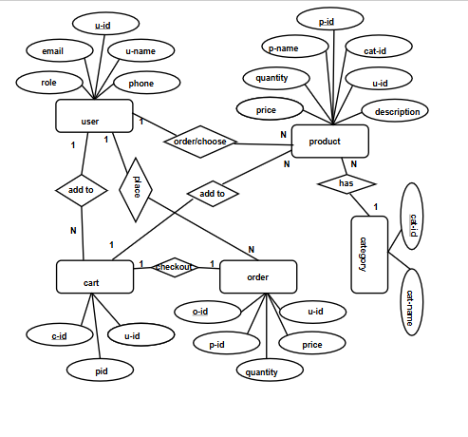

**Figure 3.3: ER Diagram of Style Hub**

#### Data Flow Diagram

A DFD is a graphical representation of the flow of data within a system. It illustrates how data is processed, stored, and transferred between different components of the system, making it a useful tool for analyzing and designing information systems.

**Context Diagram**

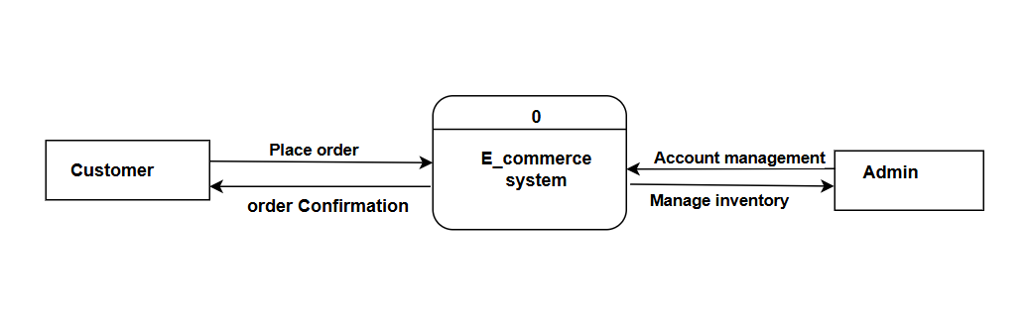

**Figure 3.4: Context Diagram of Style Hub Management System**

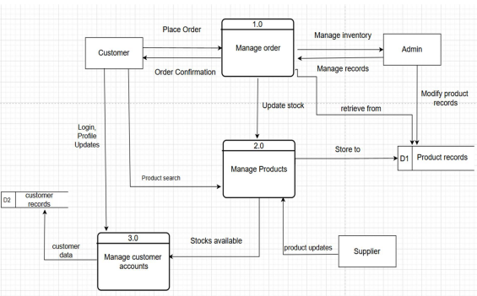**Level 0 DFD**

**Figure 3.5: level 0 DFD of Style Hub**

#### Sequence Diagram

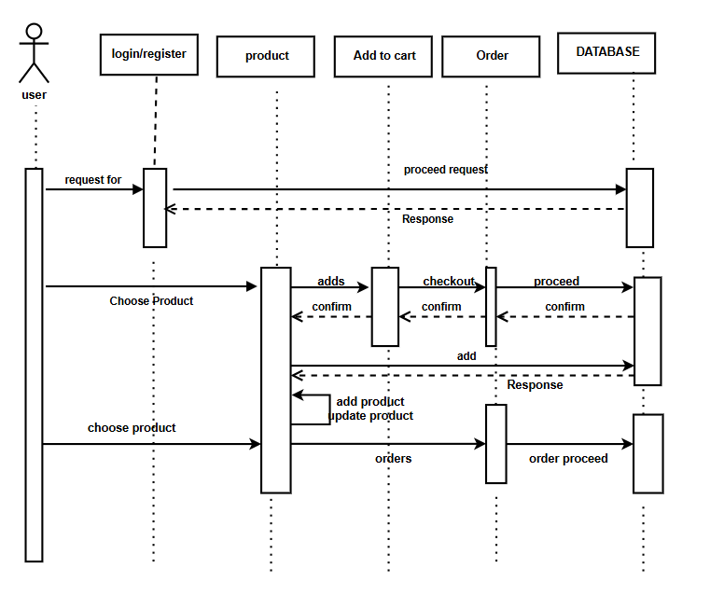A sequence diagram is a dynamic model representing the time dependent aspects of the system. Here, this diagram simply depicts interaction between activities that takes place in system.

**Figure 3.6: Sequence Diagram of Style Hub**

#### Activity Diagram

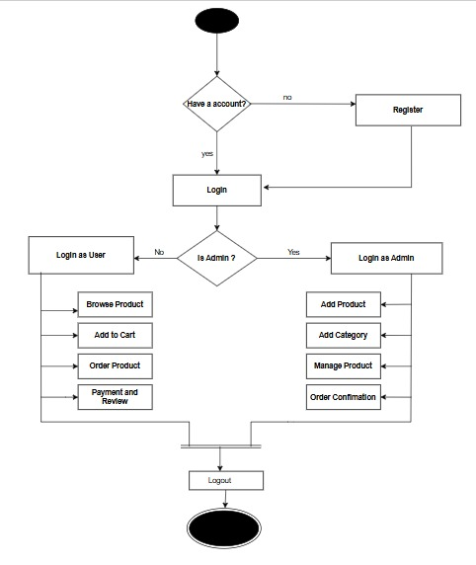Activity diagram represents the flow of control among the activities of the system. In style Hub Management System, the activity diagram shows the user, admin and other activities.

**Figure 3.7: Activity Diagram of Style hub Management System**

# CHAPTER 4.

# IMPLEMENTATION AND TESTING

**4.1** Implementation

System Implementation is mainly concerned with the building of a properly working system. It was implemented using HTML, CSS and JavaScript as a front end, PHP was used as backend programming and MYSQL was used for the database and the text editor used was Visual Studio code and XAMPP was used as the offline local server. As planned in the designed phase, ITERATIVE WATERFALL model was used as the development methodology.

### 4.1.1 Tool Used

**PHP**

PHP is used as a programming language for this project. Back end of the system is designed with PHP. PHP version: 7.4

**Html**

In our system, Html is used for creating webpages. Version: HTML 5.

**CSS**

CSS is used for designing the HTML pages and to layout the HTML documents.

**Bootstrap**

We have used bootstrap as it is a compiled CSS and JavaScript source code.

**JavaScript**

JavaScript was also used during frontend development.

**Visual Studio**

Visual Studio was used as code editor.

**MySQL**

MySQL is an open-source relational database management system. It is used to store the information of admin as well as users.

## 4.2 Testing

Testing is done in each and every project during or after the completion of product. As the project is using iterative waterfall model as software development model, the models have been kept on testing after finishing the coding. Our goal is to design a series of test cases that have a high likelihood of finding errors and reducing it.

### 4.2.1 Unit Testing

### Testing Admin Panel

**Table 1: Admin Panel Testing**

|  |  |  |  |  |  |
| --- | --- | --- | --- | --- | --- |
| Test Case ID | Test Description | Steps Executed | Expected  Result | Actual Result | Pass / Fail |
| UT-01 | Entering Incorrect e-mail or password | Incorrect email and/or passwords should be entered(Eg: Entering aparajita@gmail.com and 12345 as email and password) | Message saying invalid user or password should be displayed | Message saying Wrong Email or Password! was displayed | Pass |
| UT-02 | Entering Correct e-mail or password | Correct e-mail and/or passwords should be entered(Eg: Entering [asmita00@gmail.com](mailto:asmita00@gmail.com) and admin as email and password) | Admin Panel should be displayed | Admin panel was displayed | Pass |
| UT-03 | Clicking on User icon | Clicking on More info button of User icon | User Dashboard displayed | User Dashboard was be displayed | Pass |
| UT-04 | Deleting user | Click on Delete button | User should be deleted | User was deleted | Pass |
| UT-05 | Updating user | Click on Update button  Fill up the from and click Update | User should be | User was deleted | Pass |
| UT-06 | Clicking on Order icon | Clicking on More info button of Order icon | Order Dashboard should be displayed | Order Dashboard was displayed | Pass |
| UT-07 | Updating status of an order | Clicking on drop down box and selecting and option  Clicking on Update button | Order status should be updated | Order status was updated | Pass |
| UT-08 | Deleting order | Click on Delete button | Order should be deleted | Order was deleted | Pass |
| UT-09 | Clicking on Add Products icon | Clicking on More info button of Add Products icon | Add Products Dashboard should be displayed | Add Products Dashboard was displayed | Pass |
| UT-10 | Adding new products | Clicking on More info button of Add Products icon  Fill up the form and click on Add Product button | New product should be added | New product was added | Pass |
| UT-11 | Updating products | Click on Update button  Fill up the from and click Update Product button | Product should be updated | Product was deleted | Pass |
| UT-12 | Deleting products | Click on Delete button | Product should be deleted | Product was deleted | Pass |
| UT-13 | Clicking on Admin Panel icon | Clicking on More info button of Admin Panel icon | Admin Dashboard should be displayed | Admin Dashboard was displayed | Pass |
| UT-14 | Registering new Admin | Clicking on Register Admin  Fill up the form and click on Register button | New Admin should be added | New Admin was added | Pass |
| UT-15 | Updating Admin | Click on Update button  Fill up the from and click Update button | Admin should be updated | Admin was deleted | Pass |
| UT-16 | Deleting Admin | Click on Delete button | Admin should be deleted | Admin was deleted | Pass |

**Testing User Panel**

**Table 2: User Panel Testing**

|  |  |  |  |  |  |
| --- | --- | --- | --- | --- | --- |
| Test Case ID | Test Description | Steps Executed | Expected Result | Actual Result | Pass / Fail |
| UT-01 | Entering incorrect credentials while signing up | Incorrect credentials  should be entered(Eg: Entering aparajita as name [asmita@gmail.com](mailto:asmita@gmail.com) as email and 12345 as password and confirm password) | Message saying invalid email or password  should be displayed | Message saying invalid email or password was displayed | Pass |
| UT-02 | Entering  correct credentials while signing up | Incorrect credentials  should be entered(Eg: Entering taya as name [asmita@yahoo.com](mailto:asmita@yahoo.com) as email and 12345 as password and confirm password) | Login page should be displayed | Login page was displayed | Pass |
| UT-03 | Entering Correct e-mail or password | Correct e-mail and/or passwords should be entered(Eg: Entering [aparajita@yahoo.com](mailto:aparajita@yahoo.com) and go1234 as email and password) | Home page should be displayed | Home page was displayed | Pass |
| UT-04 | Clicking on navigation bar | Click on options of navigation bar | User should be able to navigate  through  different pages | User was navigated  through  different  pages | Pass |
| UT-05 | Clicking Add to Cart | Click on Add to Cart | Cart page should be displayed  where user can view and edit products. | Cart page was displayed | Pass |
| UT-06 | Updating product quantity | Change quantity number and click on edit button | Product quantity should be updated | Product quantity was updated | Pass |
| UT-07 | Clicking on Delete All | Click on Delete All | Cart should be empty | Cart was empty | Pass |
| UT-08 | Clicking on Proceed to Checkout | Click on Proceed to Checkout | Checkout page should be displayed | Checkout page was displayed | Pass |
| UT-09 | Clicking on Place Order | Clicking on Place Order | Empty cart should be displayed | Empty cart was displayed | Pass |

### 4.2.2 System Testing

**Test cases for System Testing**

**Table 3: System Testing**

|  |  |  |  |  |  |  |
| --- | --- | --- | --- | --- | --- | --- |
| Test Case ID | Test Case Name | Test Case Descript ion | Step Executed | Expected Result | Actual Result | Pass/  Fail |
| TC 01 | Security  Testing | Checking  Security Admin’s side to access login | Login with your registered email and password | Successful Login Directed to User Dashboard | Successful Login Directed to User Dashboard | Pass |
| TC 02 | Security  Testing | Checking  Security Admin’s side to access login | Try login with unauthorized email and password | An error messages  “Invalid  email or password” must be displayed. | An error messages  “Invalid  email or password”  was  displayed. | Pass |
| TC 04 | Usability Testing | Clicking on User icon | Clicking on More info button of User icon | User Dashboard should be displayed | User Dashboard was be displayed | Pass |
| TC 05 | Usability Testing | Deleting user | Click on Delete button | User should be deleted | User was deleted | Pass |
| TC 06 | Usability Testing | Updating user | Click on Update button  Fill up the from and click Update | User should be | User was deleted | Pass |
| TC 07 | Usability Testing | Clicking on Order icon | Clicking on More info button of Order icon | Order Dashboard should be displayed | Order Dashboard was displayed | Pass |
| TC 08 | Usability Testing | Updating status of an order | Clicking on drop down box and selecting and option  Clicking on Update button | Order status should be updated | Order status was updated | Pass |
| TC 09 | Usability Testing | Deleting order | Click on Delete button | Order should be deleted | Order was deleted | Pass |
| TC 10 | Usability Testing | Clicking on Add Products icon | Clicking on More info button of Add Products icon | Add Products Dashboard should be displayed | Add Products Dashboard was displayed | Pass |
| TC 11 | Usability Testing | Adding new products | Clicking on More info button of Add Products icon  Fill up the form and click on Add Product button | New product should be added | New product was added | Pass |
| TC 12 | Usability Testing | Updating products | Click on Update button  Fill up the from and click Update Product button | Product should be updated | Product was deleted | Pass |
| TC 13 | Usability Testing | Deleting products | Click on Delete button | Product should be deleted | Product was deleted | Pass |
| TC 14 | Usability Testing | Clicking on Admin Panel icon | Clicking on More info button of Admin Panel icon | Admin Dashboard should be displayed | Admin Dashboard was displayed | Pass |
| TC 15 | Usability Testing | Registering new Admin | Clicking on Register Admin  Fill up the form and click on Register button | New Admin should be added | New Admin was added | Pass |
| TC 16 | Usability Testing | Updating Admin | Click on Update button  Fill up the from and click Update button | Admin should be updated | Admin was deleted | Pass |
| TC 17 | Usability Testing | Deleting Admin | Click on Delete button | Admin should be deleted | Admin was deleted | Pass |
| TC 18 | Security Testing | Checking Security on User’s side to access login | Login with your registered  email and password | Successful Login Directed to User Dashboard | Successful Login  Directed to User  Dashboard | Pass |
| TC 19 | Security Testing | Checking Security on User’s side to access login | Try login with unauthorized email and password | An error messages  “Invalid  email or password” must be displayed. | An error messages  “Invalid  email or password”  was  displayed. | Pass |
| TC 20 | Usability  Testing | Clicking Add to Cart | Click on Add to Cart | Cart page should be displayed  where user can view and edit products. | Cart page was displayed | Pass |
| TC 21 | Usability Testing | Updating product quantity | Change quantity number and click on edit button | Product quantity should be updated | Product quantity was updated | Pass |
| TC 22 | Usability Testing | Clicking on Delete All | Click on Delete All | Cart should be empty | Cart was empty | Pass |
| TC 23 | Usability Testing | Clicking on Proceed to Checkout | Click on Proceed to Checkout | Checkout page should be displayed | Checkout page was displayed | Pass |
| TC 24 | Usability Testing | Clicking on Place Order | Clicking on Place Order | Empty cart should be displayed | Empty cart was displayed | Pass |

# CHAPTER 5

# CONCLUSION AND FUTURE RECOMMENDATION

## 5.1 Conclusion

"Style Hub" does a great job of carving out a specific niche in the e-commerce industry by only selling women's products like clothing, accessories, shoes, and watches. By employing the use of a B2C platform and the offering of a cash-on-delivery payment choice, the site focuses on putting trust and security first, concerns that many customers have about making purchases online. The project has a lot of potential in providing an easy and reliable solution to women who would like to purchase feminine products conveniently. Overall, the effort demonstrates a consumer-oriented approach and can attract a loyal base of users by fulfilling this niche group's requirements.

## 5.2 Future Recommendation

To enhance the functionality and reach of Style Hub, we suggest the following improvements:

Expanding Product Categories – While the current website focuses on female-oriented products, adding more categories such as beauty products, accessories, and lifestyle items could attract a broader audience.

User Experience Optimization – Implementing features like personalized recommendations, AI-driven chat support, and an intuitive user interface can improve customer engagement and retention.

Mobile App Development – Since many users prefer shopping via mobile devices, developing a dedicated mobile app for Style Hub could increase accessibility and boost sales.

Marketing and Social Media Integration – Utilizing digital marketing strategies, including SEO, social media promotions, and influencer collaborations, can help drive more traffic to the platform and improve brand recognition.

Customer Reviews and Ratings – Allowing users to leave reviews and ratings for products can build trust and help new customers make informed decisions.

Secure and Multiple Payment Options – Expanding payment methods, including wallets, UPI, and installment-based payments, can enhance convenience and attract more users.

Logistics and Fast Delivery – Partnering with reliable logistics services to ensure quick and efficient deliveries will improve customer satisfaction and loyalty.

By implementing these recommendations, Style Hub can establish itself as a leading online shopping destination for women, ensuring long-term success in the competitive e-commerce industry.

# Reference

[1] D. Chaffey, Digital Business and E-Commerce Management: Strategy, Implementation and Practice*,* 8th ed. Harlow, UK: Pearson Education, 2022.

[2] K. C. Laudon and C. G. Traver, E-Commerce 2021: Business, Technology, and Society*,* 16th ed. Harlow, UK: Pearson Education, 2021.

[3] E. Turban, C. Pollard, and G. Wood*,* Electronic Commerce 2020: A Managerial and Social Networks Perspective*,* 9th ed. Cham, Switzerland: Springer, 2020.

# Appendices

## Appendices A: Screenshots

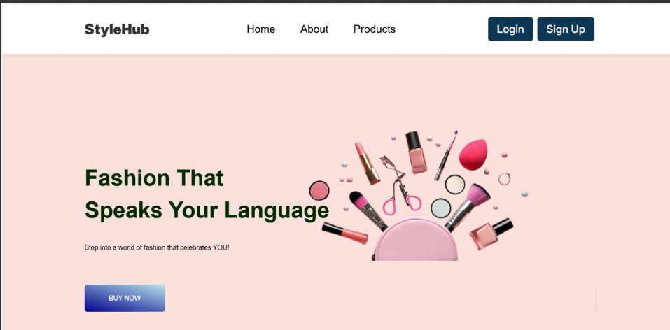**Home Page:**

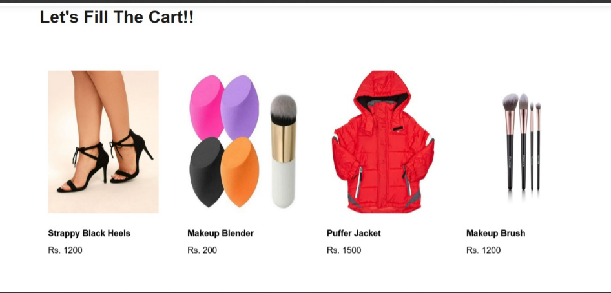

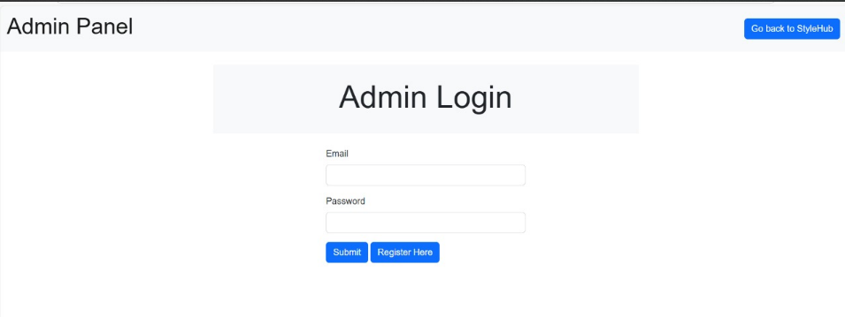**Admin Login Page:**

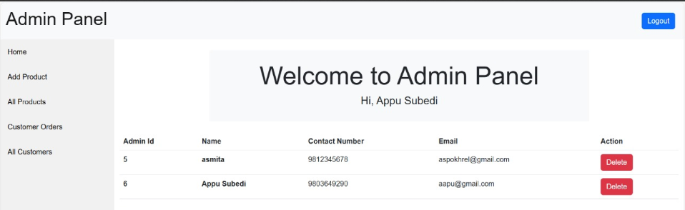**Admin Panel Page:**

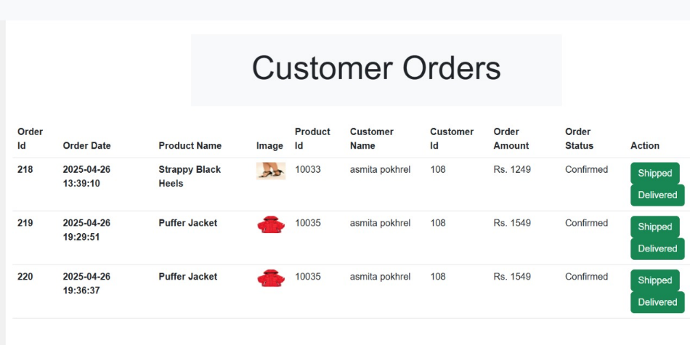**Order Panel Page:**

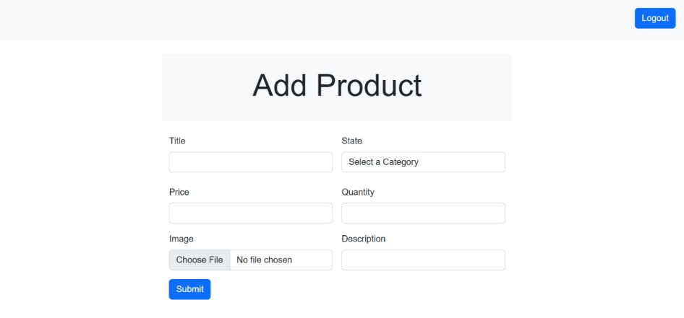**Add Product Page:**

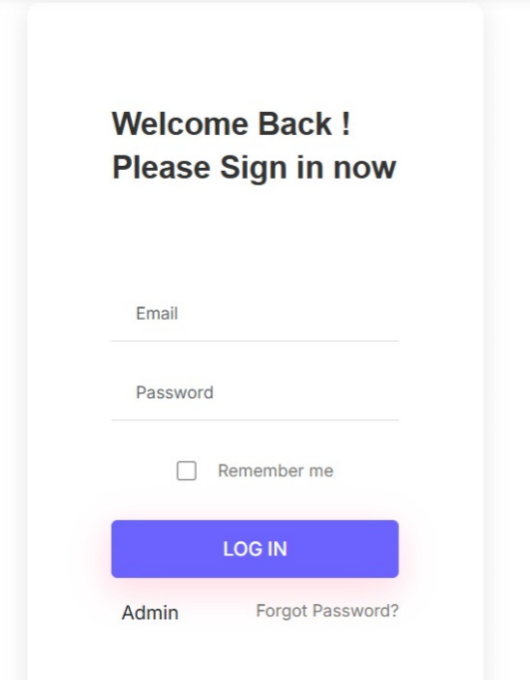**User Registration Page:**

**About Us Page:**

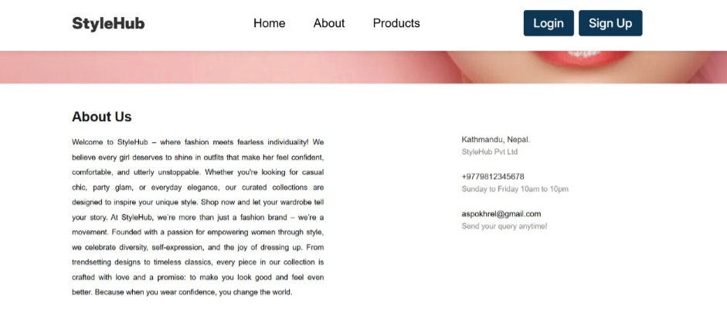

**Cart Page:**

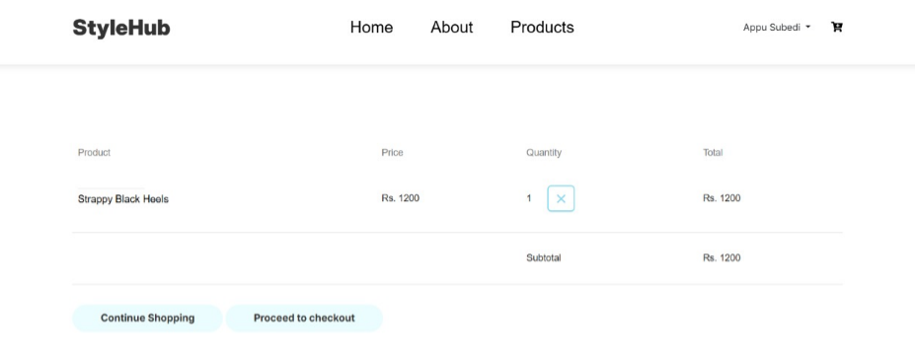

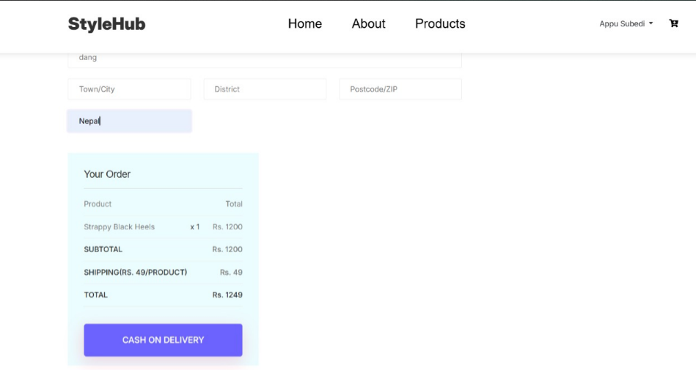 **Checkout Page:**